FRACTALS

Or Infinite Distance in Finite Area

A fractal is a rough or fragmented geometric shape that can be subdivided in parts, each of which is (at least approximately) a reduced-size copy of the whole. This property is call self-similarity. Basically, if you zoom in on one part, its going to look like the bigger picture.

The leaf of a fern is a good example. Fractals also describe many other real-world objects, such as clouds, mountains, turbulence, and coastlines, that do not correspond to simple geometric shapes.
Here is a fractal called the Koch snowflake. | 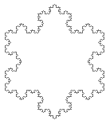
To make it, you start with an equilateral triangle. | 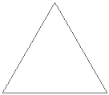

Replace each of the lines:
with something that looks like this: | 

Next, replace each of the lines:

with something that looks like this:

And so on.

Here are what the the first few stages of the Koch Snowflake look like:
 | 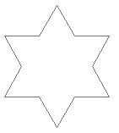 | 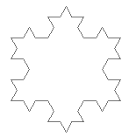
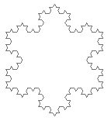

Voila. You have a fractal. Lots of other fractals can be built up in this manner, like the Sierpinski Triangle: | 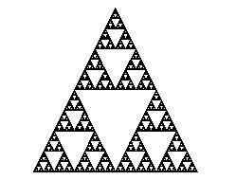

And here's an interesting, somewhat mathematical side note. Imagine you drew a circle the initial triangle used in the Koch snowflake. At no point will the Koch snowflake extend beyond the boundaries of the circle. Thus the snowflake has a finite area (since its area is less than that of the circle, which is finite). However, at every stage in building the snowflake, the perimeter is multiplied by 4/3 - it is always increasing. So the ideal snowflake (ideal meaning you go through an infinite number of stages constructing the figure) has an infinite perimeter $(\text{InitialPerimeter}\text{.}\frac{4}{3}\text{.}\frac{4}{3}\text{.}\frac{4}{3}\text{.}\frac{4}{3}\text{.}\text{.}\text{.}\text{.}\text{.}\text{.})$ yet a finite area. Its not a paradox; its simply a fractal.

